Titan SFTP Azure Marketplace Managed Plan Container Offer

End-to-End Steps from Image Update to Buyer Deployment

What is Package details section in Technical Configuration?
In an Azure Managed Application Plan in Microsoft Partner Center, the Package details section is where you upload the deployment package that customers will receive when they purchase your managed application from the Azure Marketplace.

What should be inside the ZIP package?
The ZIP file should contain the deployment artifacts for your Managed Application, typically:
package.zip
│
├── mainTemplate.json
├── createUiDefinition.json
├── nestedTemplates/
│ ├── storage.json
│ ├── vm.json
│ └── ...
└── scripts/ (optional)

The required files are:
- mainTemplate.json
  - The ARM template that deploys your solution.
- createUiDefinition.json
  - Defines the user interface shown in the Azure portal when customers deploy your application.

Azure Marketplace Container Offer
For a Marketplace container offer, your deployment package would typically include:
deployment/
│
├── mainTemplate.json
├── createUiDefinition.json
├── aks.bicep (or ARM template)
├── kubernetes/
│ ├── deployment.yaml
│ ├── service.yaml
│ ├── ingress.yaml
│ ├── pvc.yaml
│ ├── secret.yaml
│ └── hpa.yaml
└── README.md

The ARM/Bicep template can provision:
- An AKS cluster (or deploy into an existing one, depending on your offer).
- Azure SQL Database or SQL Server.
- Azure Storage Account with an Azure Files share.
- Kubernetes resources (Deployments, Services, PVCs, Secrets, etc.).

Publisher management & Customer Access
1. Publisher Management
This determines whether you (the publisher) can access and manage the customer's managed application resources.
When selected:
- You (the publisher) can access the customer's managed resource group.
Disable management access
When selected:
- You cannot access the customer's resources.
- Only the customer manages the deployment.

2. Customer Access
This determines what the customer can do inside the managed resource group.
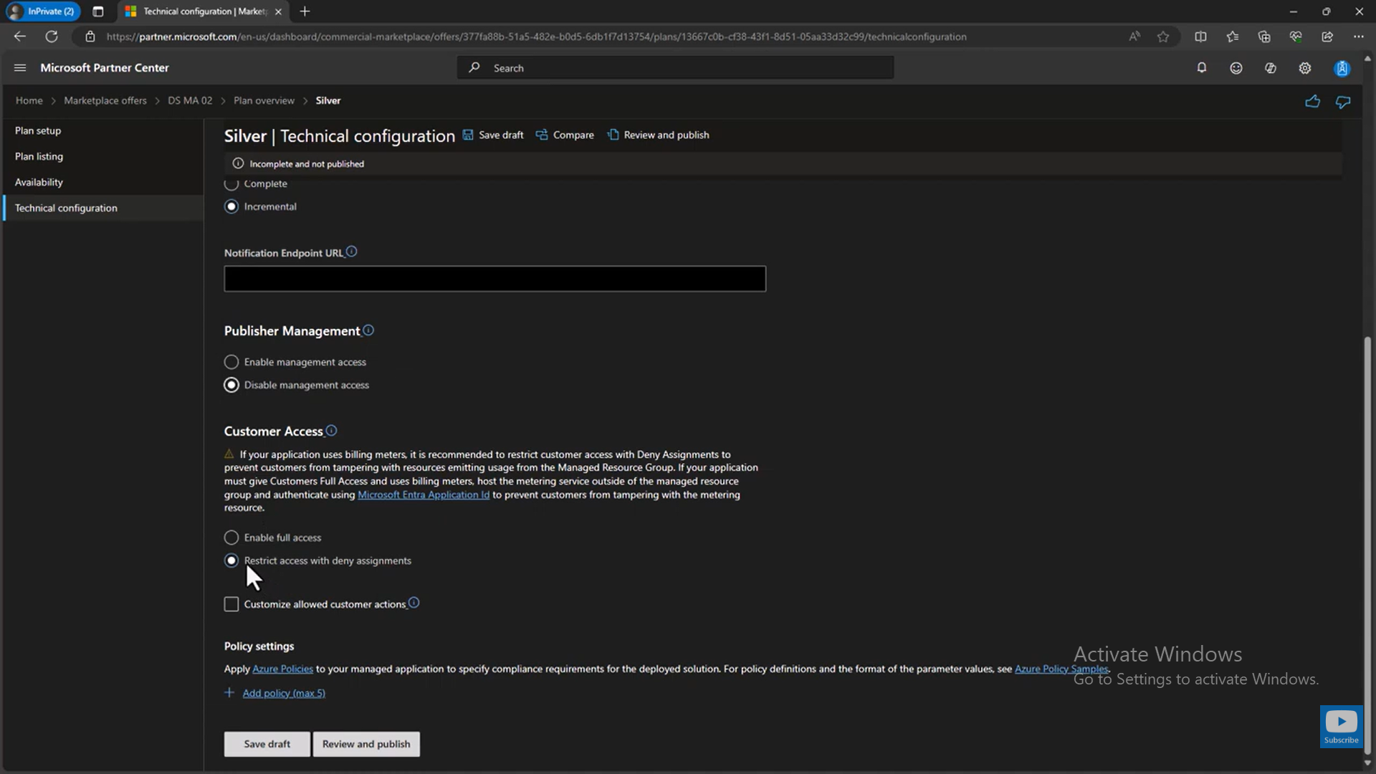

For a commercial software product where customers manage their own Azure environment, Disable Publisher Management and Enable Full Customer Access is the appropriate choice.

What are Legal Terms?
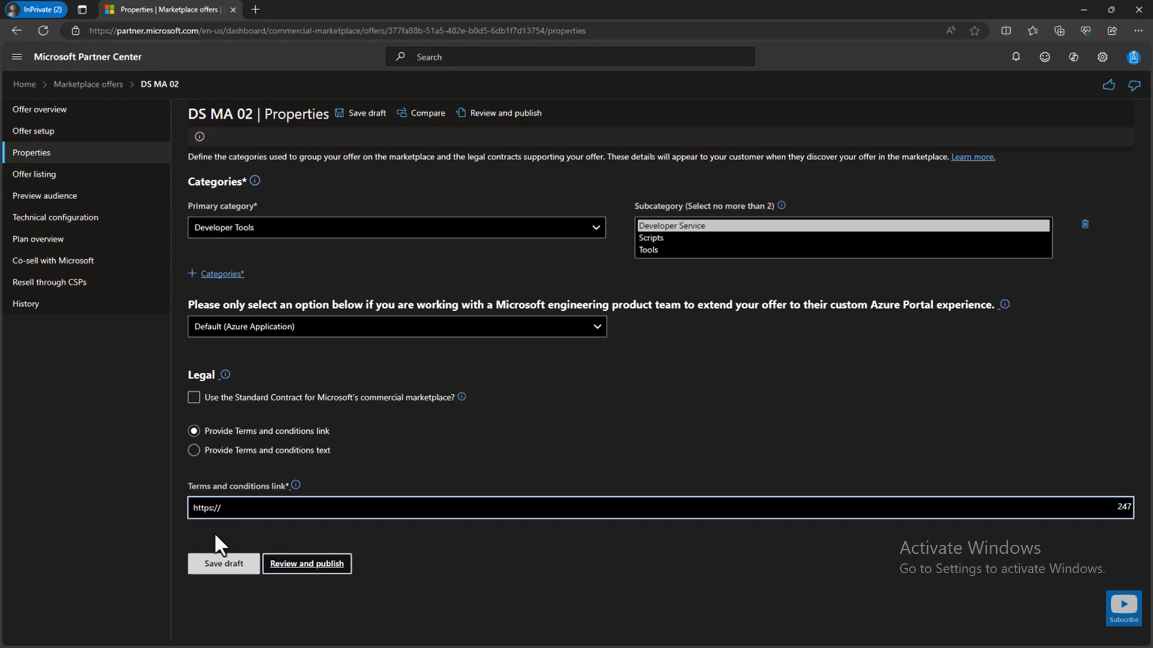
Packaging script: Script to create the deployment ZIP package for the Azure Managed Application.
Script location:
ServerCore/Source/Helm Charts/Container Offer/Azure Managed APP/titansftp-managed-app/package-managed-app.ps1
Purpose:
This PowerShell script automates the creation of the deployment package (ZIP file) required for uploading an Azure Managed Application to Partner Centre. It ensures that the package contains only the files required by Azure Marketplace, preventing unnecessary files from being included.
The generated ZIP package is used in the technical configuration → Package details section of the Azure Marketplace offer. This deployment package provides the ARM templates and configuration that enable customers to deploy the managed application successfully and allows the publisher to connect to and manage the deployed application resources after deployment.
The script packages only the required deployment artifacts:
- mainTemplate.json – The ARM template that defines the Azure resources to be deployed.
- createUiDefinition.json – Defines the user interface presented to customers during deployment, including parameters, validation rules, and deployment options.
Benefits:
- Creates the deployment package in the format expected by Azure Partner Centre.
- Ensures only the required deployment files are included.
- Eliminates manual ZIP creation and reduces packaging errors.
- Produces a consistent deployment package for every release.
- Simplifies the upload process under technical configuration → Package details for the Azure Managed Application offer.

For publisher Run command (for future versions)
Before running below commands update the current version in ..\build-and-package.ps1 file
[string]$SourceImage = "docker.io/southrivertech/titansftp-container
:26.0.0.3053-linux",
ZIP only (no ACR touch):
powershell -ExecutionPolicy Bypass -File "C:\Srt.NextGen\ServerCore\Source\Helm Charts\Container Offer\AzureManagedAPP\titansftp-managed-app\build-and-package.ps1" -Version "1.0.24" -SkipImageImport -SkipAnonymousPull -MeteringPlanId "payg-custom-metered"
Full flow (push image to ACR + build ZIP) — since the Docker Hub repo is private, pass creds:
powershell -ExecutionPolicy Bypass -File "C:\Srt.NextGen\ServerCore\Source\Helm Charts\Container Offer\AzureManagedAPP\titansftp-managed-app\build-and-package.ps1" -Version "1.0.24" -DockerHubUser "rohitsrt" -DockerHubPassword "Your_Password" -MeteringPlanId "payg-custom-metered"
Note: If you are updating the ZIP version, you must also increase the image version to keep it in sync with ACR. If the ZIP version and the ACR image version do not match, the deployment will fail.
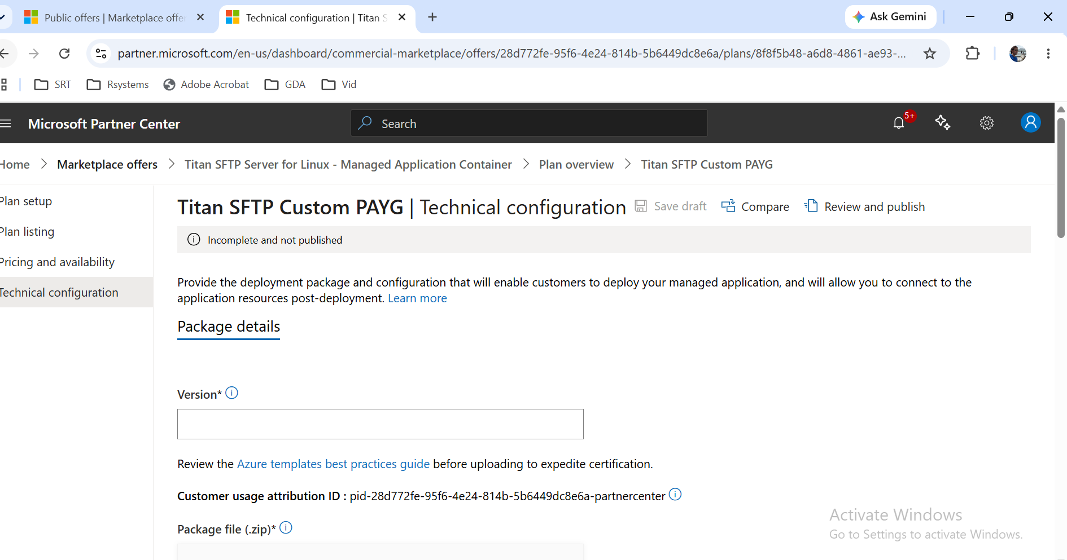

Customer Access:
Metering happens entirely inside Titan SFTP (our current design)
If:
- Titan SFTP reports usage itself.
- There is no separate metering agent.
- There is no publisher-managed service.
- Customer owns the environment.
Then choose: Enable full access.
Why is "Managed Resource Group" different from my Resource Group?
Ans:
Subscription
│
├── rohit_kapoor_rg (Customer Resource Group)
│ │
│ └── Managed Application
│
└── mrg-tn-sftp-ent-managed... (Managed Resource Group)
│
├── AKS
├── Storage Account
├── File Share
├── Public IP
├── VNet
└── Everything needed

This separation is exactly how Azure Marketplace Managed Applications are designed.

What is "Storage Account Name (optional)?
Our offer has a checkbox:
Create managed Azure File Share and mount as Titan User Data Directory.
If this checkbox is checked, the application needs an Azure Storage Account.
If you leave Storage Account Name blank:
Storage Account Name(empty) - the application will create one automatically.
Example: sttn9384723
If you specify one: “titansftpstorage”
the deployment will try to create a storage account with that exact name.

What is "File Share Name"?
Inside every Azure Storage Account, you can create multiple Azure File Shares.
Example:
Storage Account
│
├── titanfiles
├── backup
├── logs
└── uploads

By default, screen shows - File Share Name – “titansftp”
That means the deployment will create
Storage Account
|
+-- Azure File Share
titansftp

How to Find the External IP address of container Pods
az aks get-credentials --resource-group mrg-tn-sftp-ent-managed-a-20260813115444 --name titansftp-aks --overwrite-existing
kubectl get svc -A

Update Existing subscription of buyer:
Script Name: update-managed-app.ps1
What update-managed-app script does?
It allows only whitelisted operations:
- Image update (-ImageTag)
Updates both containers in StatefulSet:
  - titansftp
  - admin-setup
- Scale update (-NodeCount)
Scales:
  - AKS user node pool
  - StatefulSet replicas (kept-in sync)

Commands buyer could run
1) Scale only
powershell -ExecutionPolicy Bypass -File "C:\SRT\Work\2026\July\15-July\Code\update-managed-app.ps1" `
-ResourceGroup "rohit_kapoor_rg" `
-NodeCount 3

2) App version/image only
powershell -ExecutionPolicy Bypass -File "C:\SRT\Work\2026\July\15-July\Code\update-managed-app.ps1" `
-ResourceGroup "rohit_kapoor_rg" `
-ImageTag "1.0.16"

3) Both scale + image
powershell -ExecutionPolicy Bypass -File "C:\SRT\Work\2026\July\15-July\Code\update-managed-app.ps1" `
-ResourceGroup "rohit_kapoor_rg" `
-ImageTag "1.0.16" `
-NodeCount 3

Update Existing Buyer Subscription Using Azure Portal (UI)
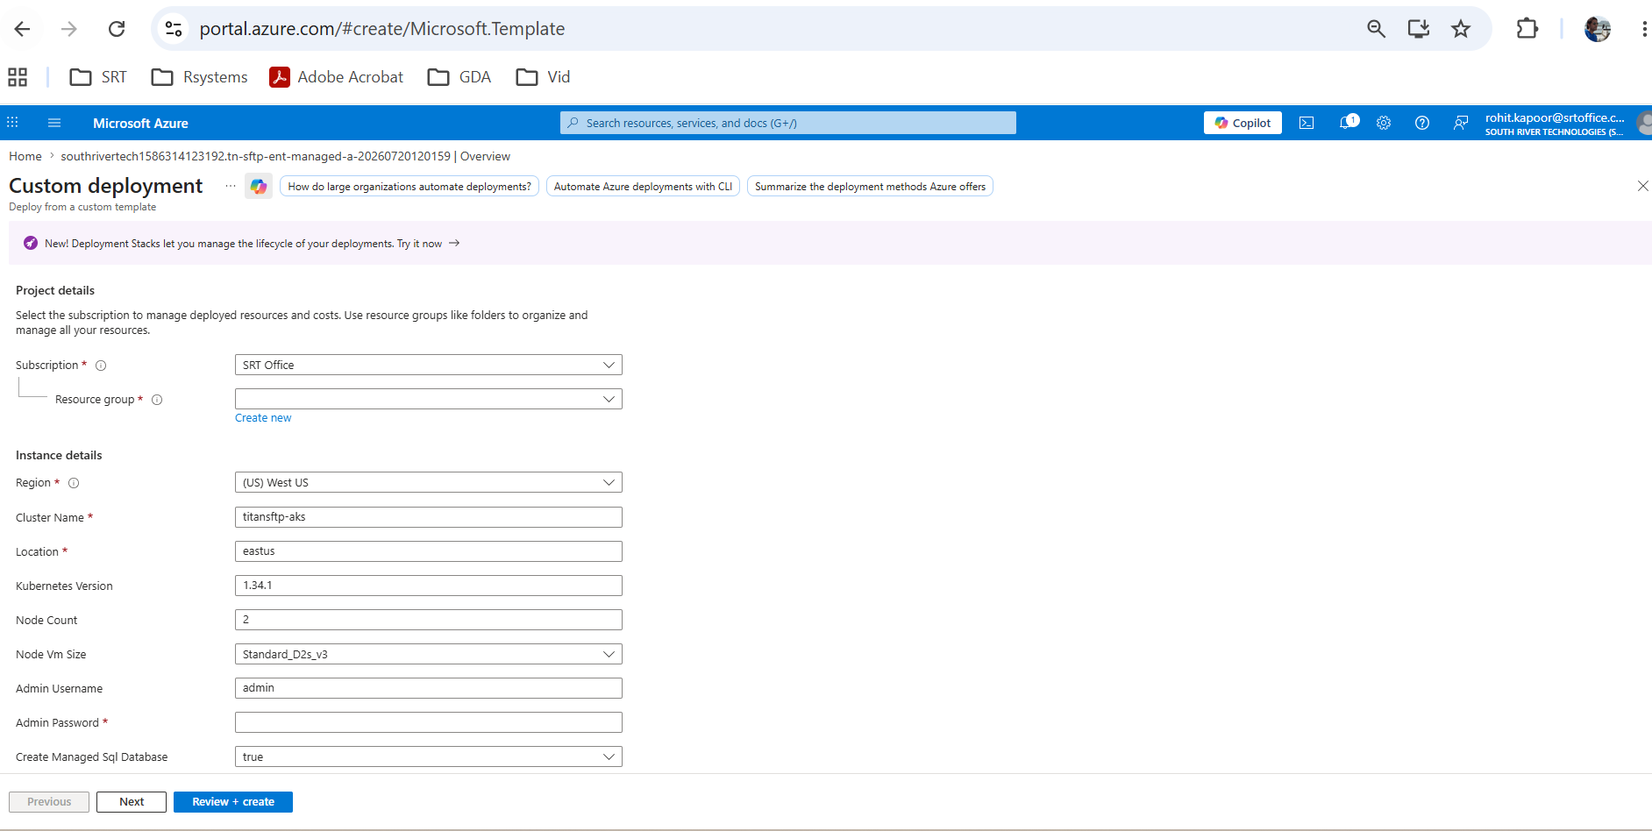
Overview
After a buyer subscribes to the Azure Managed Application, certain deployment parameters such as Node Count and Image Version can be updated without creating a new subscription.
The Azure Portal provides a Custom Deployment (Redeployment) option that allows buyers to redeploy the existing ARM template with updated parameter values
Using this method, buyers can modify deployment parameters such as:
- Node Count
- Image Version
- Other exposed ARM template parameters (if applicable)
The existing deployment is updated while preserving the deployed resources according to the ARM template logic.
Steps to Update the Deployment
Step 1: Open the Existing Deployment
- Sign in to the Azure Portal.
- Navigate to the existing Managed Application.
- Open the deployed resource.
- From the resource overview page, select Custom Deployment.

Step 2: Review the ARM Template
The Custom Deployment page displays:
- ARM Template
- Parameters file
- Subscription
- Resource Group

Step 3: Update Deployment Parameters
Select Edit Parameters.
Update the required values.
Example:
Parameter | Current Value | Updated Value
Node Count | 3 | 5
Image Version | v1.0.0 | v1.1.0

Step 4: Select Subscription and Resource Group
Verify that:
- The correct Azure Subscription is selected.
- The existing Resource Group is selected.
This ensures the deployment updates the existing resources instead of creating new ones.

Step 5: Validate the Deployment
Click Review + Create.
Azure validates:
- Parameter values
- Resource dependencies
- Deployment configuration -- Resolve any validation errors before proceeding.
Step 6: Deploy the Changes
Click Create to start the redeployment.
Azure performs an incremental deployment and updates only the resources affected by the modified parameters.

Deployment Behavior
The Custom Deployment uses Incremental Deployment Mode, which means:
- Existing resources are retained.
- Only resources affected by parameter changes are updated.
- Unchanged resources remain intact.
- Resource identities and configurations are preserved unless explicitly modified by the template.

How to search SQLite Database inside pod?
a) Open a shell inside the pod
kubectl exec -it titansftp-0 -n titansftp-system -- sh
b) Search for SQLite databases:
find / -type f \( -name "*.db" -o -name "*.sqlite" -o -name "*.sqlite3" \) 2>/dev/null
Result:
/var/southriver/srxserver/database/lasdb.db
/var/southriver/srxserver/database/srxdbDB2112AD555500000000100000000001.db

How to Copy Pod SQLite DB File to Local Windows Machine
kubectl cp titansftp-system/titansftp-0:/var/southriver/srxserver/database/lasdb.db .\lasdb.db
So, the database should be copied here: C:\Windows\System32\lasdb.db

How to Test 20 hours failure using PowerShell script:
1) Corrupt for 20h test (safe method)
powershell -ExecutionPolicy Bypass -File "C:\SRT\Work\2026\Aug\05-Aug\Azure Managed Plan\Test-Azure-Metering-Failure.ps1" -Mode Corrupt -Namespace titansftp-system -StatefulSetName titansftp -RestartStatefulSet
2) Recover
powershell -ExecutionPolicy Bypass -File "C:\SRT\Work\2026\Aug\05-Aug\Azure Managed Plan\Test-Azure-Metering-Failure.ps1" -Mode Recover -Namespace titansftp-system -StatefulSetName titansftp -RestartStatefulSet
For immediate recovery use -FastRecoveryTick (1 min).
powershell -ExecutionPolicy Bypass -File "C:\SRT\Work\2026\Aug\05-Aug\Azure Managed Plan\Test-Azure-Metering-Failure.ps1" `
-Mode Recover `
-Namespace titansftp-system `
-StatefulSetName titansftp `
-RestartStatefulSet `
-FastRecoveryTick

To Set Env Variable:
kubectl set env statefulset/titansftp -n titansftp-system CloudSettings__Metering__IntervalMinutes=60
3) Verify
powershell -ExecutionPolicy Bypass -File "C:\SRT\Work\2026\Aug\04-Aug\Azure Managed Plan\Test-Azure-Metering-Failure.ps1" -Mode Verify

Find Env Variables for AKS:
kubectl exec -n titansftp-system titansftp-0 -- printenv | Select-String "CloudSettings__Metering"

SET Env Variables for AKS:
kubectl set env statefulset/titansftp -n titansftp-system CloudSettings__Metering__Enabled=false
How to watch rollout:
kubectl rollout status statefulset/titansftp -n titansftp-system
kubectl get pods -n titansftp-system -w

